

FACULTY: Information Technology
COURSE: Multivariable Calculus and Differential Equations
COURSE CODE: MATH8213
ACADEMIC YEAR: 2025 – 2026
TEAM: 1
VENUE : Gishushu Campus
LECTURER: NIZEYIMANA Viateur
SEMESTER : 1

ID | Names | Date of Meeting | Signature
26432 | Ntaganira Habimana Happy (Chief) | 24/11/2025
24122 | Mukama Yves Thomas | 24/11/2025
24673 | Kambale Kiregha Ezechiel (Sec) | 24/11/2025
24889 | Bideri Alec | 24/11/2025
25051 | Mugiraneza Mugabo Octave | 24/11/2025
25234 | Ndeko Kaduli Jordan | 24/11/2025
26233 | Jarwin W Monboe | 24/11/2025
26317 | Ishimwe Bienvenu | 24/11/2025
26439 | Niyonkuru Arnold | 24/11/2025
26505 | Shema Jean Baptist | 24/11/2025
27354 | Munyaneza Manzi Sarto | 24/11/2025
27380 | Mushirarungu Ghislaine | 24/11/2025
27388 | Bakwiye Massa Patience | 24/11/2025
27404 | Uwera Cynthia Carmella | 24/11/2025
27409 | Teta Allen | 24/11/2025
28236 | Ineza Semuhungu Joel | 24/11/2025
28240 | Rukimirana Olivier | 24/11/2025
29061 | Mutangana Joseph | 24/11/2025
26314 | Nishimwe Diane | 24/11/2025
25711 | TUYUMVIRES Schiphtan | 24/11/2025

$$MULTIVARIABLE ASSIGNEMENT \#4$$

$${Q1.b) 3x}^{2}+{2y}^{2}-z-11=0, P(2,1,3)$$

$fx=\frac{∂f}{∂x}=6x|_{p }=>\left(6\right)\left(2\right)=>12$
$$fy=\frac{∂f}{∂y}=4y|_{p }=>\left(4\right)\left(1\right)=>4$$
$$fz=\frac{∂f}{∂z}=1|_{p }=>1$$

$${T.S=fx}_{p }\left(x-x0\right)+{fy}_{p }\left(y-y0\right)+{fz}_{p }\left(z-z0\right)$$
$${T.S=12}_{ }\left(x-2\right)+4\left(y-1\right)+\left(z-3\right)$$

$$T.S=12x+4y+z-31$$

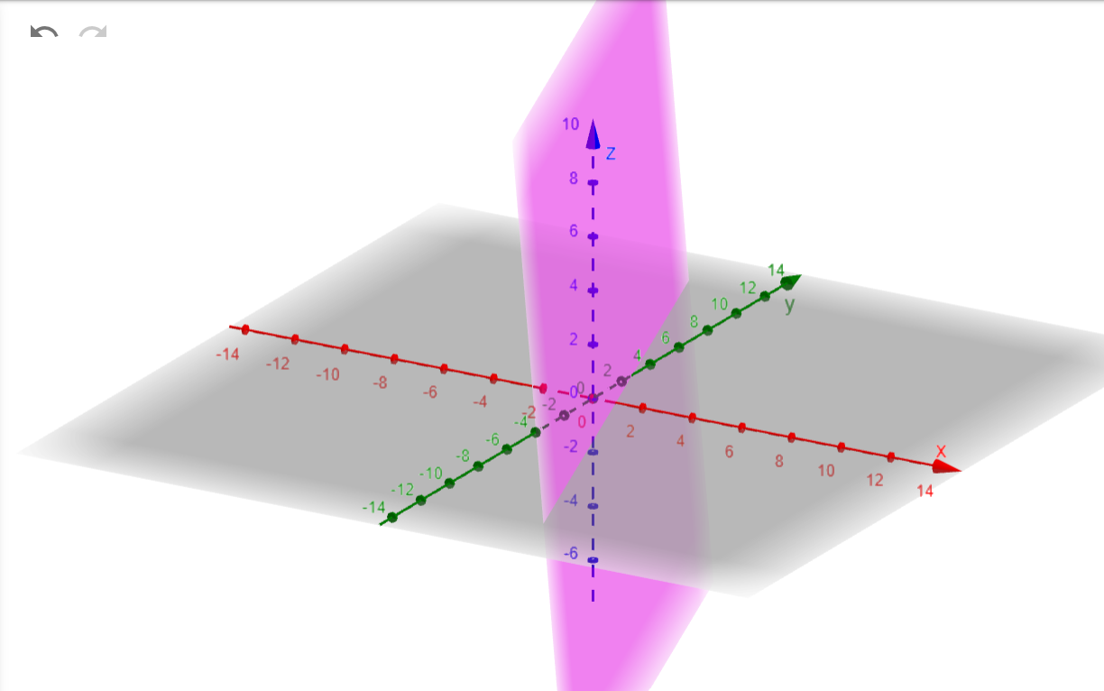
$$N.S=\frac{(x-x0)}{{fx}_{p }}+\frac{(y-y0)}{{fy}_{p }}+\frac{(z-z0)}{{fz}_{p }}$$
$$N.S=\frac{(x-2)}{12}+\frac{(y-1)}{4}+\frac{(z-3)}{1}$$
$$N.S=\frac{(x-2)}{12}+\frac{(y-1)}{4}+(z-3)$$

$${Q1.c) x}^{2}+y^{2}-z^{2}-169=0, P(3,4,12)$$

$fx=\frac{∂f}{∂x}=2x|_{p }=>\left(2\right)\left(3\right)=>6$
$$fy=\frac{∂f}{∂y}=2y|_{p }=>\left(2\right)\left(4\right)=>8$$
$$fz=\frac{∂f}{∂z}=2z|_{p }=>\left(2\right)\left(12\right)=> 24$$

$${T.S=fx}_{p }\left(x-x0\right)+{fy}_{p }\left(y-y0\right)+{fz}_{p }\left(z-z0\right)$$
$${T.S=6}_{ }\left(x-3\right)+8\left(y-4\right)+24\left(z-12\right)$$

$$T.S=6x+4y+24z-302$$

$$N.S=\frac{(x-3)}{6}+\frac{(y-4)}{8}+\frac{(z-12)}{{24}_{p }}$$

$${Q1.d) x}^{2}-2y^{2}-{3z}^{2}-4=0, P(3,1,-1)$$

$fx=\frac{∂f}{∂x}=2x|_{p }=>\left(2\right)\left(3\right)=>6$
$$fy=\frac{∂f}{∂y}=4y|_{p }=>\left(4\right)\left(1\right)=>4$$
$$fz=\frac{∂f}{∂z}=6z|_{p }=>\left(6\right)\left(-1\right)=> -6$$

$${T.S=fx}_{p }\left(x-x0\right)+{fy}_{p }\left(y-y0\right)+{fz}_{p }\left(z-z0\right)$$
$${T.S=6}_{ }\left(x-3\right)+4\left(y-1\right)-6\left(z+1\right)$$

$$T.S=6x+4y-6z-28$$

$$N.S=\frac{(x-3)}{6}+\frac{(y-1)}{4}-\frac{(z-1)}{6}$$

$${Q2.a) x}^{3}+y^{3}-63\left(x+y\right)+12xy$$
$$x^{3}+y^{3}-63x-63y+12xy$$
$fx=\frac{∂f}{∂x}= {3x}^{2}+12y-63$
$$fy=\frac{∂f}{∂y}=3y^{2}+12x-63$$

$$Calculate Critical Points$$
$$\left\{\begin{aligned}{3x}^{2}+12y-63=0 (eq1) \\ 3y^{2}+12x-63=0(eq2)\end{aligned}\right.$$

$$Eq(1) = 12y=63-{3x}^{2}$$

$$Eq1: y =\frac{63-{3x}^{2}}{12}$$
$$Eq1: y =\frac{21-x^{2}}{4}$$

Eq2: $3{(\frac{21-x^{2}}{4})}^{2}+12x-63=0$

Eq2: $3.{\frac{(21-x^{2})}{16}}^{2}+12x-63=0$
$${{3(21-x}^{2})}^{2}-1008+192x=0$$
$$expand: {{(21-x}^{2})}^{2}={4x}^{2}-42x^{2}+441$$
$Multiply by 3$ : ${12x}^{2}-126x^{2}+1323$
$$Rejoin: {12x}^{2}-126x^{2}+1323-1008+192x=0=>{12x}^{2}-126x^{2}+315+192x=0$$
$$Divide by 3: {4x}^{2}-42x^{2}+64x+105=0$$
$$Values for x that meet this equation are ±1,±3,±5,±7,±15, real solutions x= -1,3,5,-7$$
$$So if x=-1 in Eq1: y =\frac{21-x^{2}}{4}$$
If x = -1, y=5
If X=3, y=3
If x=5, y=-1
If x= -7, y=-7
$$Critical points are (-1,5),(3,3),(5,-1),(-7,-7)$$

$Second derivative$ $fx=\frac{∂f}{∂x}= {3x}^{2}+12y-63$
$fxx=\frac{∂f''}{∂{xx}^{''}}= {6x}^{ }$

$fxy=\frac{∂f''}{∂{xy}^{''}}= 12$
$fyy=\frac{∂f''}{∂{yy}^{''}}= {6y}^{ }$

$$Heissian Determinant$$
$$H =(fxx)(fyy) – (fxy)(fxy)$$
At point (3,3)
$$Fxx= 18$$
$$Fyy=18$$
$$H =(18)(18) – (12)(12)$$
$$H = 324-144=> 180 ( This is local minmum)$$
At point (-1,5)
$$Fxx= -6$$
$$Fyy=30$$
$$H =(-6)(30) – (12)(12)$$
$$H = -180-144=> -324 ( This is saddle Point)$$
$$At point (5,-1)$$
$$Fxx= 30$$
$$Fyy=-6$$
$$H =(-6)(30) – (12)(12)$$
$$H = -180-144=> -324 ( This is saddle Point)$$
$$At point (-7,-7)$$
$$Fxx= -6$$
$$Fyy=30$$
$$H =(42)(42) – (12)(12)$$
$$H = 1764-144=> 1620( This is local maxmum)$$

$${Q2.c) x}^{4}+y^{4}-{2x}^{2}+4xy-y^{2}$$
$fx=\frac{∂f}{∂x}= {4x}^{3}-{4x}^{ }+4y$
$$fy=\frac{∂f}{∂y}=4y^{3}+4x-2y$$

$$Calculate Critical Points$$
$$\left\{\begin{aligned}{2x}^{3}+2x-2y=0 (eq1) \\ 2y^{3}+2x-y=0(eq2)\end{aligned}\right.$$

$$Eq1: y= x-x^{3}$$
Plug in Eq2
$$2{(x-x^{3})}^{3}+2x-(x-x^{3})=0$$

$${Q2.d) x}^{2}+xy+y^{2}-2x-y$$
$fx=\frac{∂f}{∂x}= {2x}^{ }+y^{ }-2$
$$fy=\frac{∂f}{∂y}=x+2y-1$$

$$Calculate Critical Points$$
$$\left\{\begin{aligned}{2x}^{ }+y^{ }-2 =0 (eq1) \\ x+2y-1=0(eq2)\end{aligned}\right.$$

$$Eq: (eq1) – 2(eq2) =5y-4=0$$
$$Y =\frac{4}{5}$$
$$Plug in eq1: {2x}^{ }+{\frac{4}{5}}^{ }-2 =0$$
$$2x=-\frac{14}{5}$$
$$x=-\frac{14}{10}$$

$$Critical points (-\frac{14}{10},\frac{4}{5})$$

$$Second derivative$$
$fxx=\frac{∂f''}{∂xx''}= 2^{ }$
$fxy=\frac{∂f''}{∂xy''}= 1$
$$fyy=\frac{∂f''}{∂yy''}=2$$

$Hessian Determinant$
$H= 4-1 = 3$ (Local minimum)

$$Q2.g)$$
$$Calculate Critical Points$$
$$\left\{\begin{aligned}{2x}^{ }+y^{ }-2 =0 (eq1) \\ x+2y-1=0(eq2)\end{aligned}\right.$$

$$Eq: (eq1) – 2(eq2) =5y-4=0$$
$$Y =\frac{4}{5}$$
$$Plug in eq1: {2x}^{ }+{\frac{4}{5}}^{ }-2 =0$$
$$2x=-\frac{14}{5}$$
$$x=-\frac{14}{10}$$

$$Critical points (-\frac{14}{10},\frac{4}{5})$$

$$Second derivative$$
$fxx=\frac{∂f''}{∂xx''}= 2^{ }$
$fxy=\frac{∂f''}{∂xy''}= 1$
$$fyy=\frac{∂f''}{∂yy''}=2$$

$Hessian Determinant$
$H= 4-1 = 3$ (Local minimum)

